42.53: a) 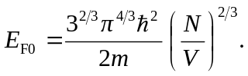
Let 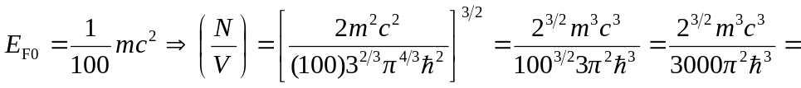
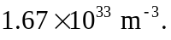
b) 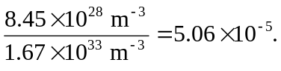
Since the real concentration of electrons in copper is less than one part in 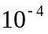of the concentration where relativistic effects are important, it is safe to ignore relativistic effects for most applications.
c) The number of electrons is 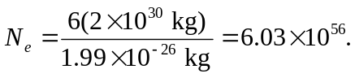 The concentration is 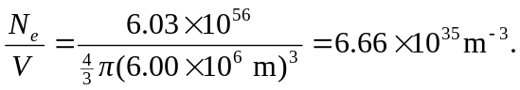
d) Comparing this to the result from part (a) 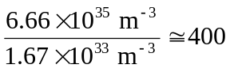 so relativistic effects will be very important.

